Manual physiological in silico digestion model (DigSim)
George van Aken
February 11, 2023
Copyright (C) 2023 George van Aken

Introduction

In this folder you will find a map that contains the physiological in-silico digestion program DigSim with several units applied by the program, a few versions of two supporting Excel workbooks.

'DigSim’ provides a literature-based simulation of the alimentary system, including food intake, mouth and gastrointestinal physiology and processing, and the responses by the body.

The program is far from not perfect, many things need to be refined, calibrated or added, but it works already quite well for topics that I used the program for (gastric emptying, glycemic effects). The settings of the program are directed to the average normal healthy individual, but by changing the modelling parameters also various individual properties can be varied, e.g., changes compared to the averaged individual related to age, diseases, or monogastric mammal type.

This program is free software. My desire is to share the programming and work together on improvements with people with different and complementary knowledge on an open-source modelling platform.

You can redistribute it and/or modify it under the terms of the GNU Affero General Public License as published by the Free Software Foundation, version 3 or any later version. This program is distributed in the hope that it will be useful, but WITHOUT ANY WARRANTY; without even the implied warranty of MERCHANTABILITY or FITNESS FOR A PARTICULAR PURPOSE. See theGNU Affero General Public License for more details. You should have received a copy of the GNU Affero General Public License along with this program. If not, see <https://www.gnu.org/licenses/>.

If the program does not work, check your computer for its decimal setting: “.” or “,” !

Please let me know if it works on your computer and what you think of it!

Manual
To use the digestion simulation program you have to first download a recent version of the free programming language Lazarus at https://sourceforge.net/projects/lazarus/. This internet page also contains a manual for Lazarus. Then from GIT you can extract the program with all its units (as pascal source codes with extension .pas), the text files meal.txt and results.txt and the excel files meal.xlsx and results.xlsx by copying the repository to a directory on your computer. For this you use the “clone repository” option: clone the repository Georgevanaken/DigSim into a map on your computer. From this map on your computer you can run the program and its helper excel files and suggest changes by pushing new version onto the DigSim repository into a different branch of the DigSim repository.

The actual program is the program DigSim in its most recent version (at the time of writing versie digsim_v76_wasserstrasse_3.pas, June 6, 2022), recognizable by the extension .pas and also its excutable recognizable by the .exe extension. To run it you may have to temporarily stop you firewall or have allowed it by the administrator of your computer. The program searches for input form meal.txt, which defines the diet as a timing of a sequence of various meals, in the same directory as DigSim, and writes output in results.xlxs in the same directory.

You can make changes in meal.txt, but it is much more convenient to use the excel workbook template for it (a few examples are attached). You can change the meal in these workbooks and save the first tab as a tab-delimited text file under the name meal.txt. In my definition, a meal consists of various compounds (a drink, a sandwich, vegetables, milk chocolate, …), has a typical particle radius, is a liquid (solid = 0) or consists of solid particles each with the same radius (“solid” in mm) and if liquid, has a viscosity (mPas)) introduced at one of each five plates a given timing. Each compound consists of a number of components (sugar, starch, water, protein, tracer components, etc.)

The meal menu starts with fields to define the menu (first sheet of the workbook, the other sheets are not really used, but can be linked to the first sheet if convenient). A menu consists of amounts (in grams) of one or more compounds (defined by compound numbers) added to one or more dishes (currently 1-5) at given times (minutes) from which the compounds are consumed at different defined rates. The purpose of the various dishes is that the compounds are not necessarily eaten together at once, but often in sequence and at different rates (e.g. a drink from a cup (e.g. dish 1) and a solid meal on a separate dish (e.g. dish 2)). An example is given below. The format is strict, the headers must remain in place, rows must remain continuous (no empty lines) and the menu must end with 9999. The number of compounds and their timing are however unlimited.

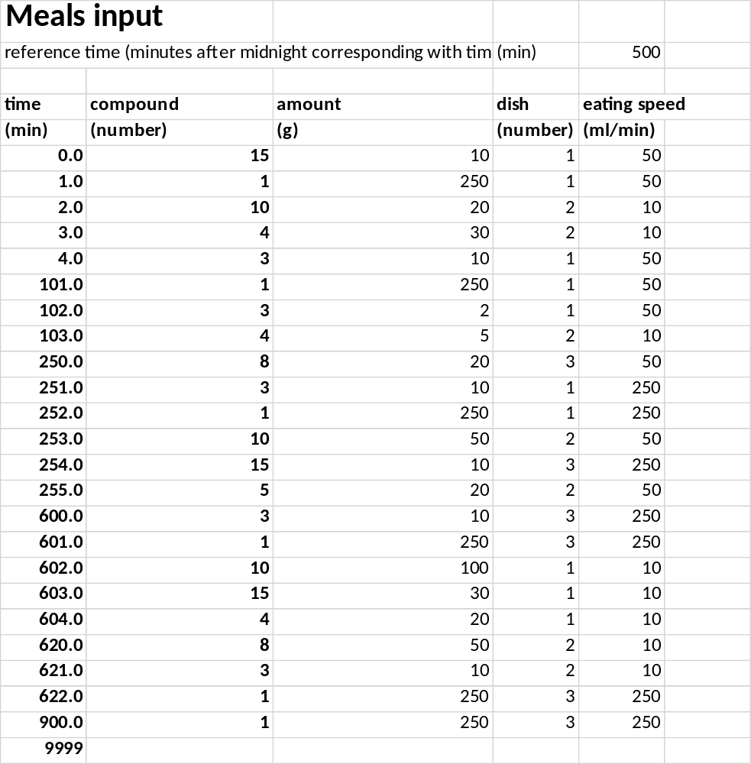

Below the menu field are the filled in which the properties and structural behavior of the compounds can be defined. It starts with the properties of the compounds, which are free to define within the following fields. New compounds can be added to the first row, but the row must end by 9999:

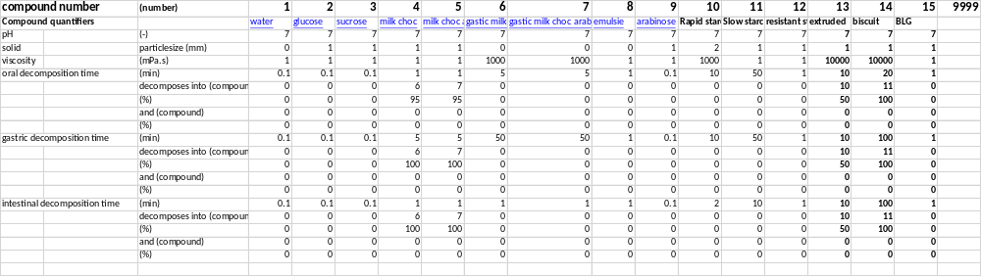
In addition to parameters such as compound pH, particle size (set to 0 for liquid) and liquid viscosity, the fields allow to include structural and compositional disintegration of the compounds. The way I do it now for general purposes is to define an first order (exponential) decay into two other compounds, for example the decomposition time of solid 1-mm pieces of chocolate in the mouth is set to 5 second in which it melts to give molten chocolate (Chocolate in stomach composition) and releases some sucrose (5% of weight). in the stomach any still remaining chocolate has similar melting time and decomposition. The molten chocolate is a high viscosity liquid, which decompose in the mouth and stomach in its components (given by compound “0”) which are fat and sugar. This approach is handy to see the effect of delayed decomposition of e.g. solids in the stomach and the half-time can be estimated from e.g. in vitro studies, but of course amore dedicated modelling of for example casein gelation and bolus erosion and the effect of pH and enzymes in this can also be included in the program itself. The particle radius of the solid compounds are used to estimate creaming or sedimentation in the stomach by Stokes law (together with the densities and viscosity of the medium) and the retention of solid particles by the Pylorus.

The last set of fields are used to define the component composition (in mass %; 80 in number) of the compounds. These components must be defined within the DigSim program as well. The % of each components in the compounds can be altered. It is possible to add new compounds and components, compounds should be added to the Excel input page and components to the Excel input page and in the Pascal program itself.

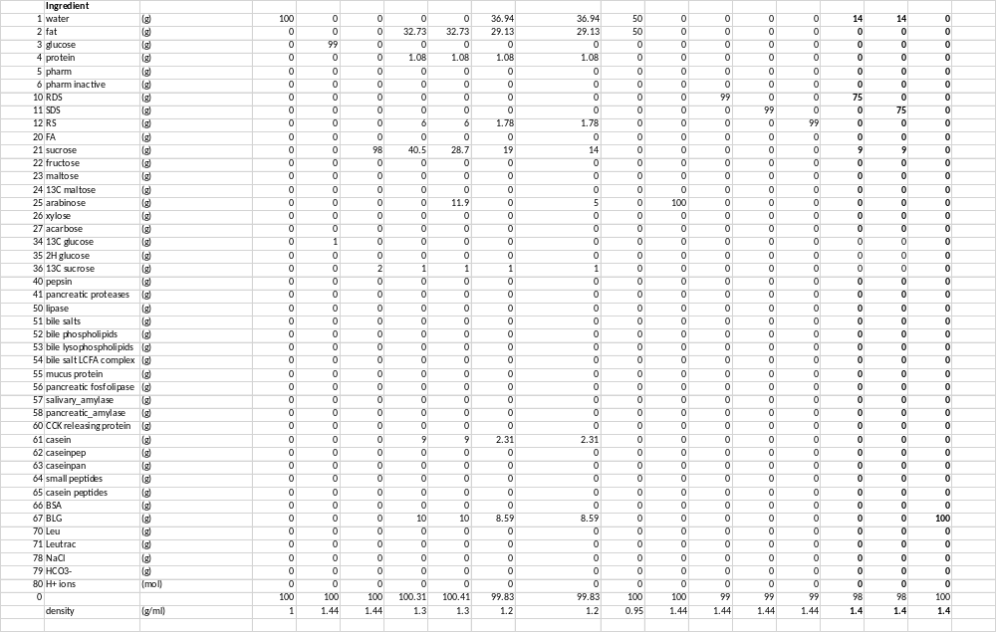

Changes made in the Meal workbook can be saved under any name for storage, but to make it available for the DigSim program, the first sheet of the workbook should be saved as a tab-delimited text file “meal.txt” in the same directory as the DigSim Pascal program or its exe.file. This can be done through the “save as” command in Excel, which then lists a table of options.

Next you run DigSim by simply clicking on it, which in case of clicking on the file with exe extension stats the executable of the program, or in case of clicking on the file with .pas extension stats the Lazarus screen from which you can run the .pas file (or first alter it). The internal parameters are currently set to an average individual in the program. It will open with a screen asking you the number of calculation steps per minute, the larger more accurate and slower. For a quick reasonable assessment I usually chose 16 or 18, for an accurate calculation for example 60 or 63. After entering this number, the program starts with an equilibration for 500 min up to the fasted state (8 stars, each star corresponds to the completion of 1 hour simulated time) and will then show the subsequent additions of meals (and simulated hours by stars). After the last meal the simulation is continued for 5 hours (eight stars) after which the program stores data for each full minute. Because the simulated stomach in the program has a peristaltic cycle of 3 times per minute, it matters if the chosen step size is 1 plus a multitude of 3 or not (if not, you will see the variations related to the different stages in the gastric peristalsis). Digsim automatically stores the output in the same directory as the Digsim program under results.txt; earlier versions of this output file will be overwritten.

You can extract and plot the data from the tab-delimited result.txt file with any preferred graphing program, but for easy extraction and visualization I added the “Simulated” Excell workbooks, which shows a lot of graphs related to the data in result.txt, and the data can be updated/refreshed by the “Refresh” option in the Excel menu bar, after which you can also adjust the directory from which Excel should retrieve the results file. Of course you can save a new “Simulated” workbook under any desired name.

